Name: Maloth Aditya

Roll No.: 120CS0124

Given an initial state of an 8-puzzle and final state to be reached: -

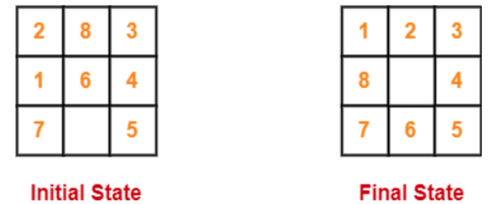

Find the most cost-effective path to reach the final state from the initial state using the A* algorithm.

Consider g(n)=Depth of node and h(n)=Number of misplaced tiles

**A* Algorithm:**

**Code:**